SAMPLE INPUT AND OUTPUT SHOWCASING THE FILE HANDLING PROGRAM
#TASK 1
# INPUT: FOR MERGING TWO TEXT FILES
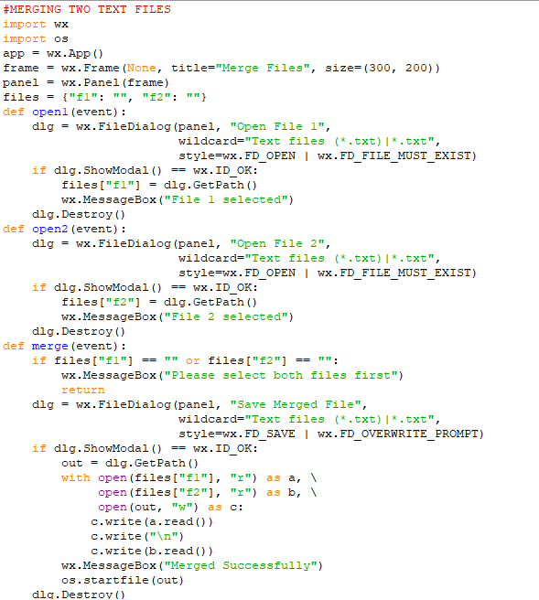
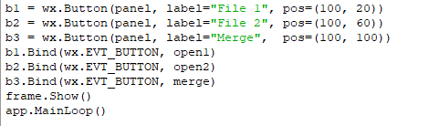

#OUTPUT OF MERGING TWO TEXT FILES
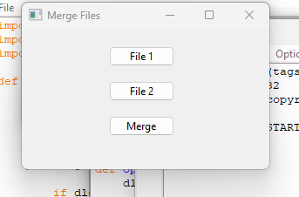

MERGED CONTENT OF BOTH THE FILES IN ONE FILE

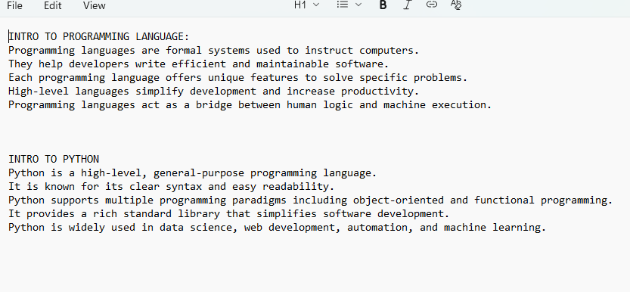

#TASK 2
#CREATE LOG FILE AND COUNT ERRORS
INPUT
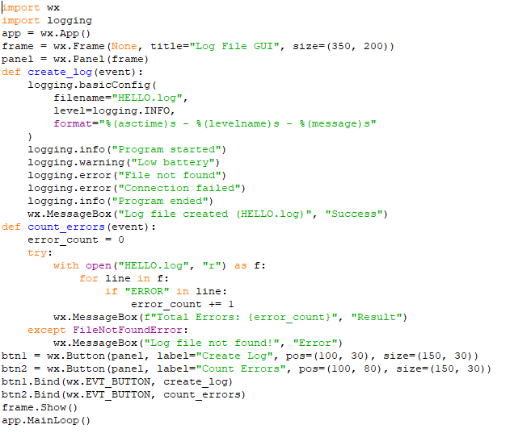
OUTPUT
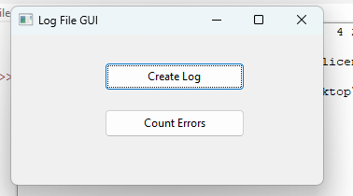
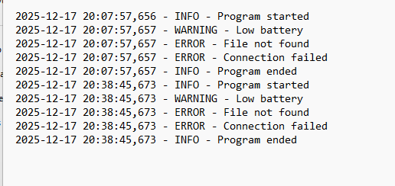
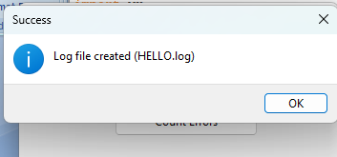
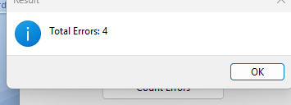

#TASK 3
#DISPLAY AND AND UPDATE STUDENTS RECORD

INPUT
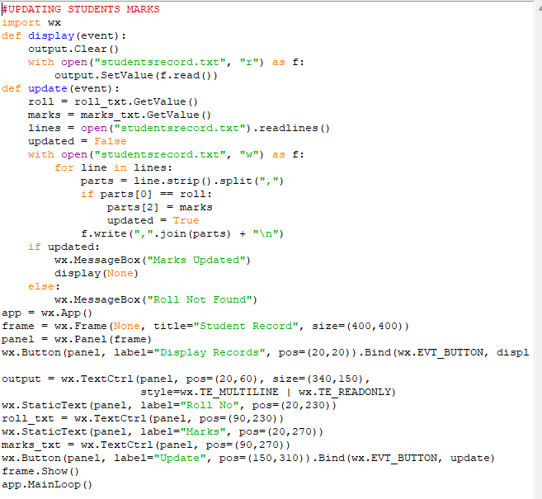

OUTPUT
